Control law comparison — 6 drives, 8 control channels

Control law comparison
Six drives, eight control channels, low-damping frame (sdynpy_frame6x12_system.npz). Thirty-one runs, 2026-09-12 to 2026-09-20. Revision of the 2026-09-15 report.
Three things are new since the last revision. The fast optimal-diagonal law appears here as a real run for the first time — the two rows that carried its name in the twelve-run matrix did not execute its algorithm. A startup level cap and two live-FRF guards have been added to the laws and are documented here with the failures that motivated them. And every number in both tables has been recomputed under one method, so the historical and current results can be read against each other.
What a reader of the 2026-09-15 report needs to know Runs 05 and 06 are labelled optimal_diagonal_control_fast in that report and in the run files. They were the base class. The conclusion drawn from them — that the fast law matches the exact law closely — happened to be approximately right for the wrong reason, and the real measurement is in §3.

1. What the columns mean
rms dB | RMS of 10·log10(measured / specification) over all eight control channels and all in-band lines (100–1000 Hz).
% >6 dB | Percentage of channel×line points outside ±6 dB. Note this is a ±6 dB tolerance; the session notes quote a ±3 dB figure, which is roughly double.
floor | Best achievable RMS error at this run's own FRF, from achievable_response.achievable_diagonal with restrict_rcond = 1e-3, every 5th in-band line, log-interpolated between solved lines. Not a constant — see §8.
vs floor | The run's error measured against its own floor rather than against the specification. This is the part attributable to the control law.
loop | What the law closes on. error: the measured response error. model: the identified plant model only — it re-solves against the live FRF but never looks at the measured response. none: one-shot synthesis, no loop at all. These labels changed on 2026-09-21 — see the note below.
level dB | Total in-band power, measured against specification.
drive | Mean in-band drive trace. Saved spectra are test-level normalised, so this is comparable across runs taken at different test levels.

2. The twelve-run matrix — historical baseline
Unchanged in substance from the 2026-09-15 report, recomputed here under the current method. Six laws, drive-coherence cap on and off.
The loop column has now changed twice, and this is the version to keep. The 2026-09-15 report called both optimal-diagonal laws feedback laws. That was wrong, and the correction made on 2026-09-17 relabelled them open loop — which over-shot, because it reads as though the plant model were frozen, when re-solving against a moving FRF is precisely what those laws do and what the 2026-09-19 work was about. Two different loops are at issue:
- model — the optimal-diagonal family. Closed on the identified plant model: the live FRF goes to _refine_batch every cycle, bins whose H moved are re-solved, and bins whose predicted error degraded against the current H are re-solved worst-first. Open on the response error: the objective is the predicted response diag(H X H^{H}), and last_response_cpsd was accepted and never read. So a level-dependent FRF change is tracked, but error the FRF does not explain is invisible. §7 closes that half.
- error — match_trace_pseudoinverse (a trace ratio) and match_diagonal_congruence (a per-drive log error). These integrate the measured response error.
- none — pseudoinverse_control and buzz_control: one-shot syntheses, replayed unchanged.
No measured result in this table changed — only the label. But any conclusion in the 2026-09-15 report that leaned on “feedback laws do X”, and any in the 2026-09-17 or 2026-09-20 versions that leaned on “these laws are open loop”, should be re-read with this in mind.
run | law | cap | loop | rms dB | % >6 dB | floor | vs floor | level dB | drive
run01 | match_trace | 0.95 | error | 8.22 | 27.5 | 3.88 | 7.16 | +0.09 | 0.12
run02 | match_trace | off | error | 7.21 | 21.1 | 3.90 | 5.78 | +0.05 | 6.02
run03 | optimal_diagonal | 0.95 | model | 5.62 | 11.2 | 3.64 | 3.99 | +0.08 | 0.0747
run04 | optimal_diagonal | off | model | 5.62 | 11.2 | 3.61 | 3.99 | +0.41 | 0.079
run05  NOT the fast law — see §2 | optimal_diagonal_fast | 0.95 | model | 5.64 | 10.9 | 3.75 | 3.99 | +0.26 | 0.076
run06  NOT the fast law — see §2 | optimal_diagonal_fast | off | model | 5.66 | 10.7 | 3.61 | 3.99 | +0.06 | 0.0756
run07 | congruence | 0.95 | error | 5.31 | 19.8 | 3.63 | 3.51 | +2.85 | 0.0469
run08 | congruence | off | error | 5.23 | 18.7 | 3.57 | 3.48 | +2.78 | 0.211
run09 | pseudoinverse | 0.95 | none | 10.47 | 42.1 | 3.92 | 9.55 | +13.55 | 5.45
run10 | pseudoinverse | off | none | 7.01 | 17.8 | 3.92 | 5.48 | -1.28 | 5.38
run11 | buzz | 0.95 | none | 7.90 | 30.2 | 3.82 | 6.75 | +9.38 | 0.981
run12 | buzz | off | none | 5.91 | 13.6 | 3.85 | 4.20 | -0.30 | 1.47
Why runs 05 and 06 are not fast-law data The fast law decides per call whether it is safe to use its unconstrained factored solve, by asking whether the FRF has moved since the last call. Until 2026-09-17 that test was bitwise equality. With “Update Transfer Function During Control” enabled — which is how all twelve runs were taken — Rattlesnake republishes an incrementally averaged FRF every cycle, so the array was never bit-identical, every bin fell through to the base class's SDP, and the law was byte-for-byte optimal_diagonal_control. It was only ever fast in the configuration it was least needed in. That the two rows nonetheless sit within 0.02 dB of runs 03 and 04 is not evidence about the fast law; it is the same law twice.

3. The four key laws on the current code
All four re-run between 2026-09-18 and 2026-09-20 on the code as it now stands, each with the drive-coherence cap at 0.95 and the FRF update on.
run | law | cap | loop | rms dB | % >6 dB | floor | vs floor | level dB | drive
run34 | optimal_diagonal | 0.95 | model | 5.64 | 11.1 | 3.71 | 4.01 | +0.12 | 0.0745
run32 | optimal_diagonal_fast | 0.95 | model | 6.08 | 12.5 | 3.68 | 4.49 | +0.01 | 0.018
run20 | congruence | 0.95 | error | 5.39 | 20.1 | 3.76 | 3.59 | +3.04 | 0.0836
run33 | match_trace | 0.95 | error | 8.15 | 27.6 | 3.89 | 7.05 | +0.17 | 0.187
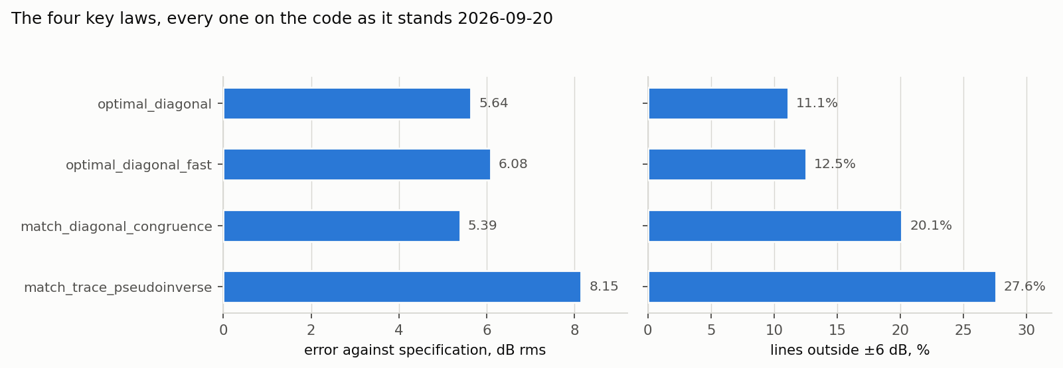
Two measures of the same four runs. They are in different units, so they get two panels rather than two y-axes on one plot.
Two of the four are in good shape and two are not, for different reasons. optimal_diagonal_control is the accuracy benchmark and is stable across three code generations: 5.62 dB on run 03 (09-12), 5.68 on run 19 (09-18), 5.64 on run 34 (09-20), with drive within 0.4 % across all three. The fast law now runs its own algorithm and lands 0.44 dB behind it for roughly a quarter of the drive.
match_diagonal_congruence looks better than it is. Its 5.39 dB rms is second best on the board, but 20.1 % of its lines sit outside ±6 dB against optimal diagonal's 11.1 %, and it runs +3.04 dB hot. A low rms with that many lines out means the errors are balanced, not small. Forcing the overall level to 0 dB makes every measure worse — computed offline, rms 5.39→5.97 and the per-channel bias goes from 1.40 dB average high to 1.64 dB average low, because the +3 dB is what holds the two unreachable channels up. The level offset is not the problem; the per-line scatter is, and its cause is not yet known.
match_trace_pseudoinverse is the weakest, and now known to be weak for a structural reason rather than a stale-code one. Run 33 reproduced run 01 to within a tenth of a dB on every accuracy measure after eight days and three sets of changes to the file it lives in. Its per-channel mean bias runs [−2.08 −2.86 −2.57 −2.32 −0.86 −0.96] on the six reachable channels and −6.81/−7.48 on the two unreachable ones — every channel below specification — while the overall level sits at +0.17 dB. That is only possible if a minority of lines sit far above. The law computes one real scalar per frequency line, spec_trace/response_trace, and scales the whole drive CPSD by it. The trace is therefore correct by construction and the distribution across the eight channels is whatever the pseudoinverse happens to give. Nothing in the law controls it.

4. The fast law, measured properly
Once the gate was fixed the factored solve turned out to have a failure mode of its own, and the sequence below is how it was found and bounded.
run | law | cap | loop | rms dB | % >6 dB | floor | vs floor | level dB | drive
run22 | optimal_diagonal_fast | 0.95 | model | 9.91 | 37.5 | 3.90 | 9.02 | +14.29 | 0.954
run23 | optimal_diagonal_fast | 0.95 | model | 6.56 | 15.8 | 2.14 | 5.59 | +3.55 | 0.316
run24 | optimal_diagonal_fast | 0.95 | model | 6.30 | 13.8 | 3.18 | 4.91 | +0.75 | 0.17
run25 | optimal_diagonal_fast | 0.95 | model | 6.61 | 16.2 | 3.13 | 5.44 | +1.17 | 0.178
run27 | optimal_diagonal_fast | 0.95 | model | 6.27 | 14.1 | 3.38 | 4.80 | +0.55 | 0.272
run29 | optimal_diagonal_fast | 0.95 | model | 6.06 | 12.3 | 3.45 | 4.55 | -0.10 | 0.0189
run31 | optimal_diagonal_fast | 0.95 | model | 6.04 | 12.2 | 3.65 | 4.44 | -0.07 | 0.0205
run32 | optimal_diagonal_fast | 0.95 | model | 6.08 | 12.5 | 3.68 | 4.49 | +0.01 | 0.018
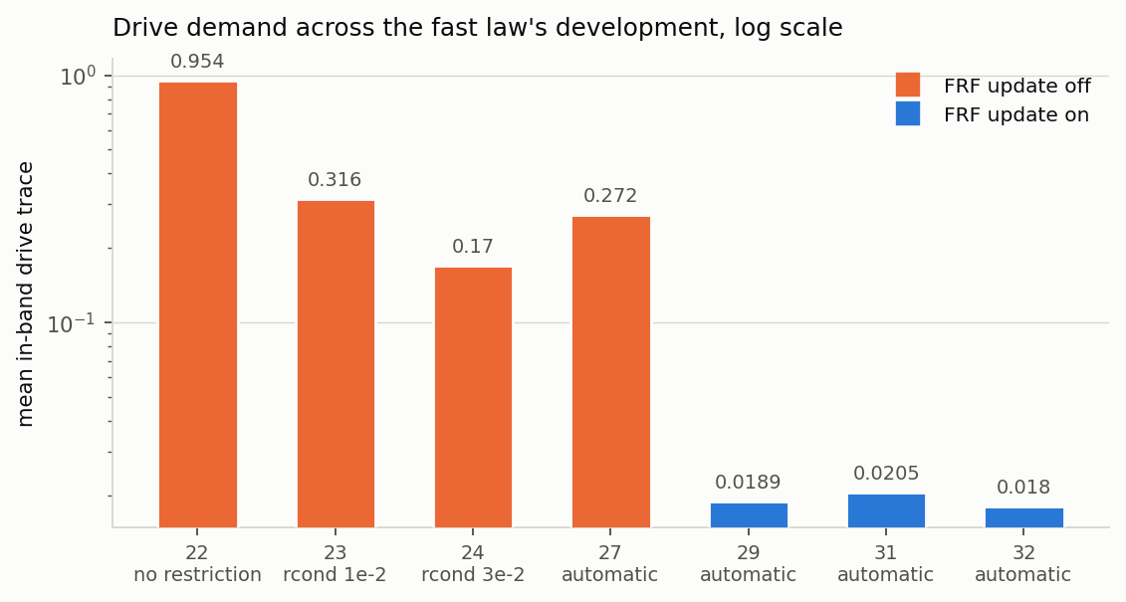
Mean in-band drive trace across the fast law's development. Log scale: the range spans a factor of 53.
Run 22 is the failure. With the factored path unconstrained in its default linear error domain, the solve commanded a drive whose predicted response was −0.39 dB and whose measured response was +14.29 dB, at 17.8 V. The solution was not wrong — it was unrealizable. Its accuracy lived in cancellation between drives that survives only if the drive is reproduced to a precision no rig delivers. Perturbing the commanded drive by 1 % offline predicts +16.69 dB, which brackets what the rig actually did.
drive_rcond is the fix. It confines the factored solve to the right-singular directions of H carrying σ ≥ rc·σ₁, so the objective cannot buy accuracy with drive down a near-null direction. Swept on the rig at 0, 1e-2, 3e-2 and 5e-2, the optimum was 3e-2. It is now expressed as a multiple of the plant's own singular-value spread — default 2.0 — because this frame's smallest structural direction sits at σ₅/σ₁ = 0.0152 and 2.0×0.0152 = 0.030 is the swept optimum. On a differently conditioned article the multiple tracks the plant where an absolute ratio would not. Runs 26 and 27 derived 0.0302 and 0.0303 from two fresh identifications without being told.
The FRF update turned out to matter more than the sweep. With the update off, the same commanded solution produced wildly different drive from run to run — 0.170, 0.538, 0.272 on runs 24, 26 and 27. With it on, three runs measured 0.0189, 0.0205 and 0.0180: a factor of 14 lower and reproducible to 7 %. Solving against a plant model that tracks the plant as driven removes the inter-drive cancellation the rig cannot reproduce. Runs 29, 31 and 32 are three independent confirmations, and the acceptance bands for the second and third were registered in the run sheet before those runs were taken.
The honest trade The SDP is still more accurate: 5.64 dB against 6.08, and 11.1 % of lines out against 12.5 %. The fast law's case is drive and time — about a quarter of the drive trace, and roughly 3.6× faster per bin on real data (not the 18–20× that synthetic-FRF benchmarks suggested).

5. The startup level cap
On the first control cycle there is no measured response yet, so a law falls back to a raw solve on whatever FRF the spectral processing has produced so far — which on the first frame is a single noisy unaveraged estimate, with no minimum-frames gate upstream. On real hardware this was observed to overshoot by several decades. The cap clamps the predicted response trace of that one command to startup_test_level_cap_db re the specification trace, default −9 dB.
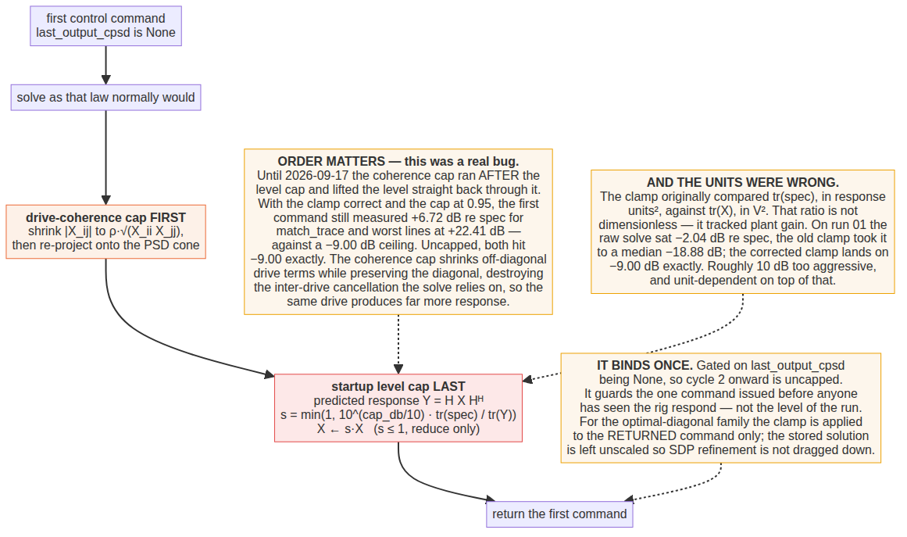
The startup cap, and the two bugs found in it on 2026-09-17.
Two things about it were wrong until 2026-09-17 and are worth recording, because both were silent.
The units. The clamp originally compared the specification trace, in response units squared, against the drive trace, in volts squared. That ratio is not dimensionless — its value tracked plant gain and response-channel units. On run 01's identification the raw solve sat at −2.04 dB re specification and the clamp as written took it to a median −18.88 dB. The corrected clamp lands on −9.00 dB exactly.
The order. Both callers ran the drive-coherence cap after the level clamp, which lifted the level straight back through it. With the clamp correct and the cap at 0.95, the first command still measured +6.72 dB re specification for match_trace_pseudoinverse and +22.41 dB on the worst single line, against a −9.00 dB ceiling. Uncapped, both hit −9.00 exactly. The coherence cap shrinks off-diagonal drive terms while preserving the diagonal, which destroys the inter-drive cancellation the pseudoinverse solve relies on, so the same drive produces far more response. The safety ceiling now goes last.
The cap binds on the first command only, in every law that has one. It guards the one command issued before anyone has seen the rig respond; it is not a level limit for the run.

6. The two live-FRF guards
Added 2026-09-19 to optimal_diagonal_control, and therefore inherited by optimal_diagonal_control_fast and octave_band_switching_control. They are not inherited by match_diagonal_congruence or match_trace_pseudoinverse, which are a standalone class and a plain function respectively.
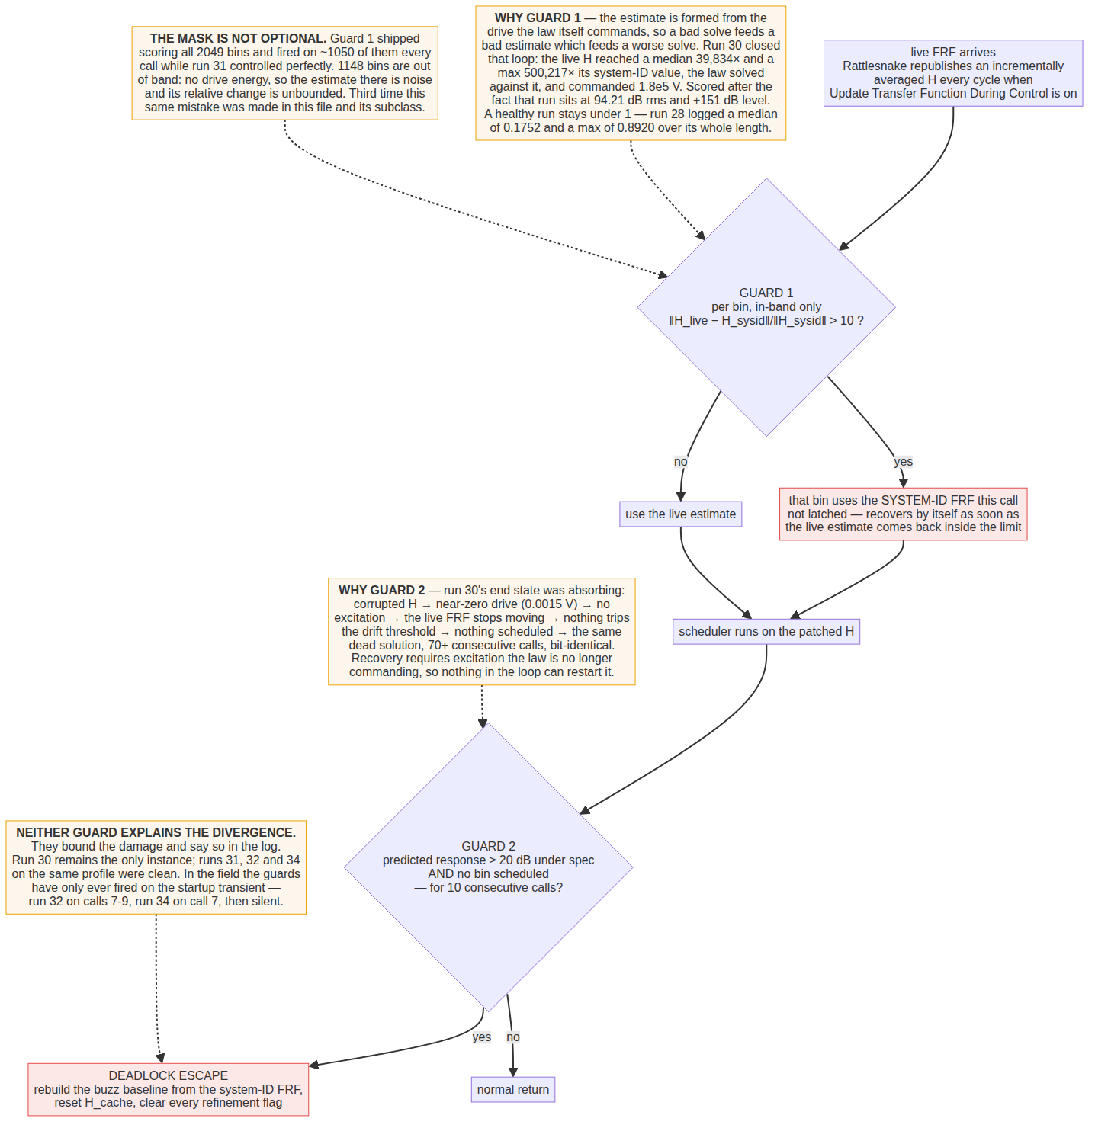
The two guards, and the run-30 failure each exists for.
Run 30 is why. With the FRF update on, Rattlesnake republishes an incrementally averaged estimate every cycle — formed from the drive the control law itself commands. A bad solve therefore feeds a bad estimate which feeds a worse solve. Run 30 closed that loop: the live FRF reached a median 39,834× and a maximum 500,217× its system-identification value, the law solved against it, and commanded 1.8×10⁵ V. Scored after the fact, that run sits at 94.21 dB rms, 100 % of lines out, and +151 dB level — and its own FRF reads numeric rank 2 rather than 5.
The demotion gate did not help, and that is the lesson. It fired correctly throughout run 30, demoting 69 % of calls to the coherence-capped SDP. Falling back to the safe solver cannot rescue a solve when the plant model is wrong, because both solvers get the same bad H. The gate protects against solver fragility; it was never a defence against estimator divergence, and those are different failures.
The end state was absorbing. Corrupted H produced a near-zero commanded drive (0.0015 V), which meant no excitation, so the live FRF stopped moving, so nothing tripped the drift threshold, so no bins were scheduled, so the law kept commanding the same dead solution — seventy consecutive calls with every scheduler field zero and a bit-identical self-prediction. Nothing in the loop could restart it, because restarting requires excitation the law was no longer commanding.
What the guards have and have not done Verified offline: on ordinary 3 % averaging jitter neither guard fires and the control output is bit-identical to the pre-guard code, so nothing in runs 01–29 is invalidated. In the field they have only ever fired on the startup transient — run 32 on calls 7, 8 and 9 covering 4, 20 and 3 in-band bins, and run 34 on call 7 covering 15. Two different laws, the same call numbers, the same handful of bins: that excursion is a property of the rig's startup, not of either law. Run 30 remains the only divergence, and its trigger is unexplained. Runs 31, 32 and 34 on the same profile were clean. The guards bound the damage; they do not explain it.

7. The response-error trim — closing the second loop
Added 2026-09-21, after the runs in this report. Off by default and not yet run on the rig, so nothing in the tables above reflects it.
The gap it closes is the one named in the note in §2. The optimal-diagonal family corrects whatever the FRF explains, because it re-solves against the live FRF every cycle. It cannot correct what the FRF does not explain — bias in the H1 estimate, extraneous input, drive clipping, a nonlinearity that never appears in a linear FRF. With no integral action on the measured response, such an offset simply stands, and the only sign of it is the law's own self-consistency diagnostic reading near 0 dB while Rattlesnake's Response Error panel reads high.
Two design choices carry the whole thing, and both were settled on paper before any code was written.
What is integrated. Not measured-versus-predicted, which is the obvious choice and is wrong: for a constant multiplicative plant bias b that ratio reads 10log₁₀(b) for ever whatever the trim does, because shrinking the target shrinks prediction and measurement together. It is a mismatch readout, not an error, and an integrator driven by it runs to its clamp and stops there. The trim integrates measured-versus-specification instead — the quantity the test is judged on — which converges geometrically to the right correction.
What is excluded. Integrating measured-versus-specification alone would wind up at every bin the plant cannot reach, and this frame is rank 5 with six drives. So the trim is applied only where the solver reached what it aimed at, judged by the law's own predicted error against its own target, both cached from the cycle that issued the command. A shortfall the solver itself predicted is an achievability limit, not model error.
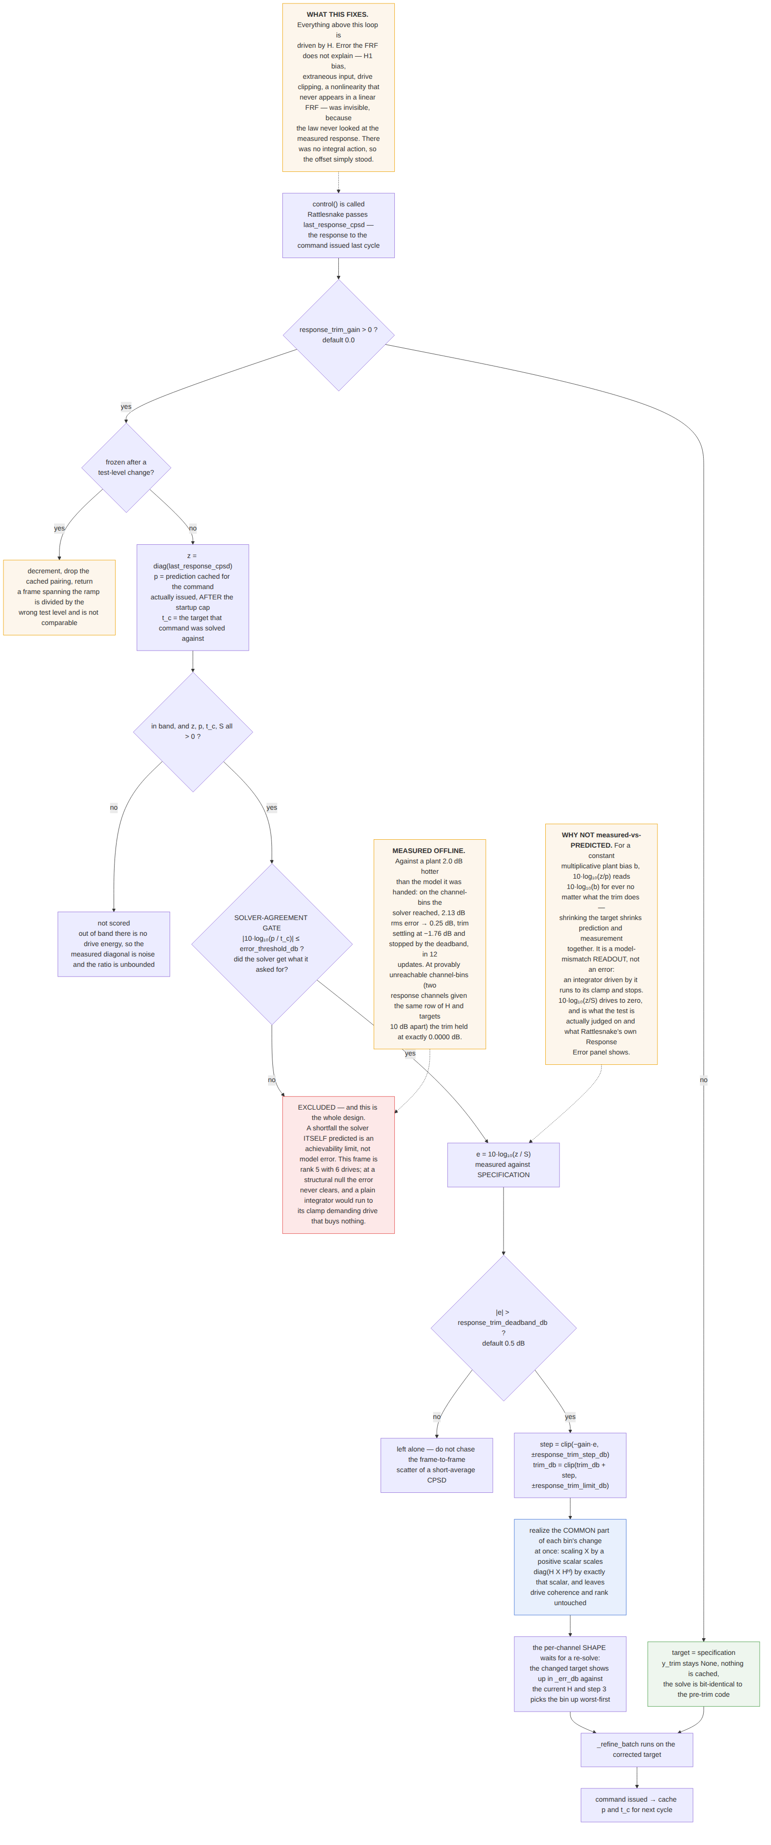
The response-error trim. Which error signal is integrated, and the solver-agreement gate that keeps it from winding up at bins the plant cannot reach.
Bounded by a 0.5 dB per-cycle step, a ±3 dB total authority clamp and a 0.5 dB deadband; scored in band only; and stood down for three cycles across a test-level change, because components/data_collector.py divides each acquired frame by the current test level and a frame spanning the ramp is normalised by the wrong number.
Offline results (verify_response_trim.py, four tests, all passing). With the gain at 0 the command is bit-identical to the committed code on real run-29 data, max |new − committed| = 0.000e+00 — the test that had to hold, since otherwise every archived run would be in doubt. Against a plant 2.0 dB hotter than the model it was handed, on the channel-bins the solver reached: rms error 2.13 dB → 0.25 dB, trim settling at −1.76 dB and stopped by the deadband, in twelve updates. At provably unreachable channel-bins — two response channels given the same row of H and targets 10 dB apart, the solver's own shortfall a median 5.00 dB — the trim held at exactly 0.0000 dB.
What the rig still has to answer. Offline the plant bias was uniform, constant and exactly known. On the rig it is none of those. The open questions are whether the trim and the FRF-update loop interact badly when both are moving, what the deadband-to-noise ratio really is against a short-average CPSD, and whether ±3 dB of authority is the right amount of rope. The runsheet pre-registers bands for all three.

8. A method finding: the floor is not a constant
Every “vs floor” number in this report is computed from the run's own FRF, and that turns out to matter more than expected.
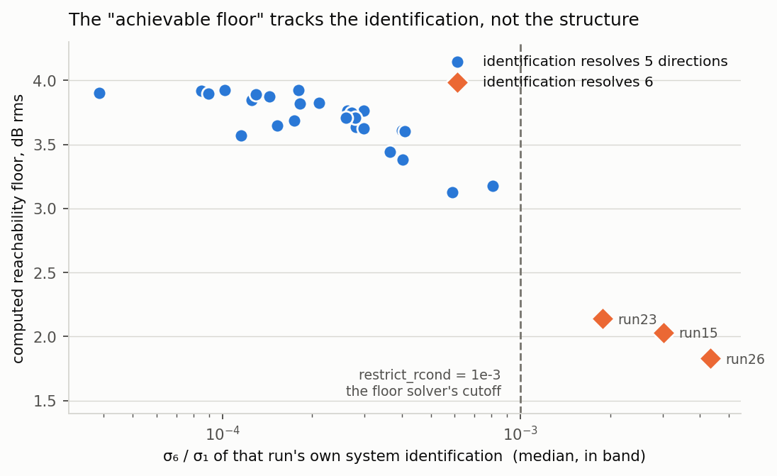
Each point is one run. Run 30 is omitted: its FRF reads numeric rank 2 and its floor is not meaningful.
The floor solver keeps drive directions with σ ≥ 1e-3·σ₁. This frame is structurally rank 5, and on most identifications the sixth singular value sits near 1e-4 — comfortably below that cutoff, so the solver works with five directions and the floor lands between 3.13 and 3.92 dB. On runs 15, 23 and 26 the identification happened to lift σ₆/σ₁ above 1e-3; the solver got a sixth direction, and the floor collapsed to 1.83–2.14 dB.
So “error against the floor” is not comparable across runs whose identifications differ in quality. Run 26's apparently poor 5.61 dB against its floor and run 32's 4.49 are not measuring the same thing: run 26 is being judged against a floor that assumes a sixth drive direction the structure does not have. The sixth singular value is identification noise, not a property of the plant — which is exactly why drive_rcond finds the structural floor by gap detection rather than by taking σ_{min}.

9. What is open
- The response-error trim has never been run on the rig. Four offline tests pass, including the bit-identical regression with the gain at 0, but offline the plant bias was uniform, constant and exactly known. Until it has run, the trim is a proposal with a test behind it, not a result.
- Run 30's trigger. One instance, unexplained. Same profile, same test level, comparable identification, and three clean runs around it.
- Congruence per-line scatter. 20.1 % of lines outside ±6 dB against optimal diagonal's 11.1 % at a lower rms. Cause unknown. This, not the level offset, is the real congruence problem.
- Congruence repeatability. Never run twice on identical code. This matters because the offset analysis in §3 was computed from a single run, and drive has been shown not to repeat on three other laws.
- Plant coverage. All 31 runs are on one plant, the low-damping frame. Five others sit unused in the results directory, and drive_rcond's automatic threshold has only ever been exercised on this one.
- octave_band_switching_control inherits both guards and has never been run in this campaign.
Generated 2026-09-20, revised 2026-09-21 (loop classification corrected; §7 added), from report_data.json (31 runs, recomputed under one method by examples/sixdrive12resp/code/compute_report_data.py). Flow charts from Claude outputs/flowcharts/*.mmd. Companion document: Control laws in the Rattlesnake MIMO random environment, same date, which documents each law's algorithm in detail.

